1.<https://drive.google.com/file/d/1qYhbXHkOeuakY8ANfFtaBPuDZYCW9Svm/view?usp=sharing>

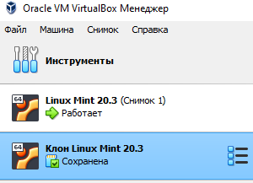

2. network address translation (NAT) - Connection type assigned to each virtual machine by default. Meets the minimum requirements for working on the Internet and does not require initial configuration.

NAT connects the guest OS to the external network, isolating it from direct connections from the outside.

NAT imitates a connection to a router. The router is the Virtualbox network module, which processes outgoing packets and forwards them to the host system, in the same way incoming traffic is processed. A router is created between each virtual machine and the host system. Through this separation, the virtual machine becomes protected from contacts with other machines and intrusions from the external network.

The virtual machine receives its network address from the built-in DHCP server. The machine is assigned an address in the range 10.0.X.0/24, where "X" is the interface address given by the formula +2. So "X" will be 2 if there is only one active NAT interface. The guest operating system will be assigned the address 10.0.2.15, the network gateway will be assigned the address 10.0.2.2, the name server (DNS) will be assigned 10.0.2.3.

Network Bridge emulates a card connected directly to the network. The adapter is connected to a distribution device within the network, after which the machine receives a standard ip-address from its range and another "computer" appears in the network.

All connections between the virtual machine and the external network are made through the host computer's physical network card. If you have several network cards, then you can choose the card that will serve the connection. This is done on the Name tab, which appears if Network Bridge is selected as the connection type.

Virtual host adapter - the mode creates a network between the host system and the virtual machine, bypassing the physical network card. A software network interface appears on the computer, which serves to exchange data between virtual machines and the host system. Virtual machines can connect to each other and the host system as if connected through a switch. As with internal network mode, the virtual machine is not provided with a physical interface, so the machines cannot communicate with the external network.

The VirtualBox Host-Only Network device appears on the host system. It has its own subnet 192.168.56.0 and a gateway address - 192.168.56.1. The device connects the subnet and the host system without direct access to the external network.

Internal network - The connection type simulates a closed network, accessible only to the machines included in it. The network is completely closed to the host system and other external devices.

An internal network is similar to network bridge mode. As in bridge mode, a machine can communicate with other machines on its network, but cannot access outside of it. Since none of the machines has direct access to the physical network adapter of the host system, the network is completely closed, inside and out. The network itself is created automatically when you select this type of connection. The mode has no additional settings, the user can only change the network name.

An example of using an internal network is the Whonix system, which consists of two virtual machines. One machine acts as a gateway to the TOR network, the second machine is the working system. The working system connects to the gateway through the internal network, which in turn sends all traffic to TOR.

3.- 1.To view network settings, use the command:

ifconfig  
 This will show you the network interfaces and their IP addresses.

2.To configure network settings, you can edit the configuration file for the network interface. For example, if you want to edit the configuration file for eth0, use the command:

sudo nano /etc/network/interfaces.d/eth0.cfg  
 This will open the configuration file in the nano editor.

3.To set a static IP address for the network interface, add the following lines to the configuration file:

auto eth0 iface eth0 inet static address [IP_ADDRESS] netmask [NETMASK] gateway [GATEWAY]  
 Replace [IP_ADDRESS], [NETMASK], and [GATEWAY] with the appropriate values for your network.

4.To apply the changes, restart the networking service with the command:

sudo service networking restart

5.To verify that the network settings have been applied, use the command:

ifconfig  
 You should see the updated IP address for the network interface.

-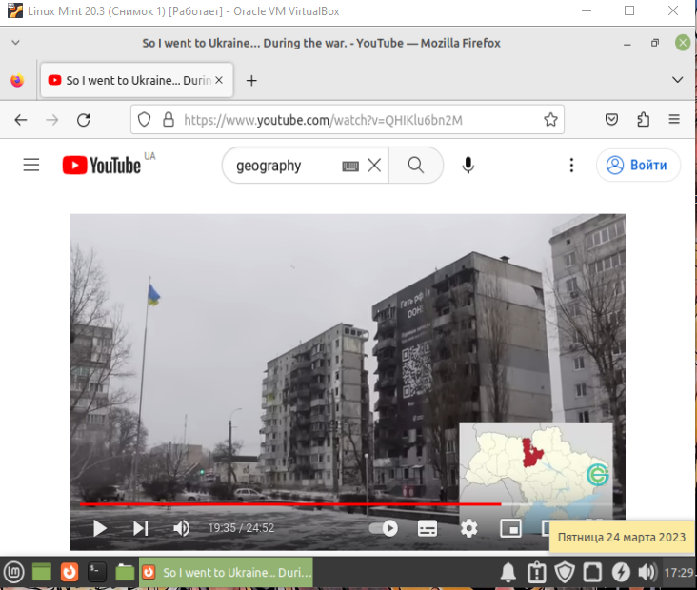

-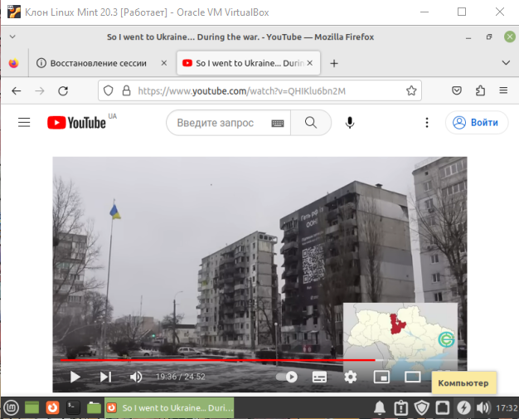

4.-There are several ways to organize the exchange of information between your main operating system (OS), such as Windows, and virtual OSes. Here are a few options:

1. Shared Folders: You can set up shared folders between your main OS and the virtual OS. This allows you to easily transfer files between the two operating systems without the need for external storage or network transfers. Most virtualization software, such as VirtualBox and VMware, support shared folders.
2. Drag and Drop: Many virtualization software support the ability to drag and drop files between your main OS and the virtual OS. This can be a quick and easy way to move files between the two operating systems.
3. Clipboard Sharing: Clipboard sharing allows you to copy and paste text and other data between your main OS and the virtual OS. This can be particularly useful when working with text-based applications or when copying configuration settings.
4. Network Shares: If you need to transfer large files or folders between your main OS and the virtual OS, you can set up network shares. This will allow you to access files and folders on your main OS from within the virtual OS and vice versa.

Overall, the best approach will depend on your specific needs and the virtualization software you are using. It is important to ensure that you have the necessary permissions and security settings in place to prevent unauthorized access to your data.

-To copy a document from the virtual OS desktop to your main desktop, you can use the shared folders feature or network sharing to transfer the file. Once the file is in the shared folder or network share, you can access it from your main desktop by navigating to the appropriate folder.

To reverse the action and copy a file from your main desktop to the virtual OS desktop, you can follow the same process in reverse. For example, if you are using shared folders, you can copy the file from your main desktop to the shared folder, and then access it from within the virtual OS.

Alternatively, you can use the drag and drop or clipboard sharing methods to transfer files between the virtual OS and main desktop. To copy a file from your main desktop to the virtual OS using drag and drop, simply drag the file from your main desktop and drop it into the virtual OS desktop. Similarly, to use clipboard sharing, you can copy the file from your main desktop to the clipboard, and then paste it into the virtual OS desktop.

In summary, the specific steps to copy a file from the main desktop to the virtual OS desktop will depend on the method you are using to transfer the file, such as shared folders, network shares, drag and drop, or clipboard sharing.